

|  |
| --- |
| **MSI Technical Documentation** |

Author: Mariel Escano

February 5, 2015

Confidential

# Copyright

Copyright © 2011 Gurango Software Corporation

All rights reserved.

Information in this document is prepared by Gurango Software Corporation for MSI ECS in preparation for Dynamics CRM 2011 Customer Service Management implementation. The software described in this document is furnished under a license agreement or nondisclosure agreement. The software may be used or copied only in accordance with the terms of those agreements. No part of this document may be reproduced, stored in a retrieval system, or transmitted in any form or by any means without the prior written permission of **MSI ECS.**

**Gurango Software Corporation**

Units 7-8 G/F Topy's Place Building,

Industria cor. Economia St.,

Barangay Bagumbayan, Libis, Quezon City

Philippines 1110

Telephone: + 63 (2) 637-0928

Facsimile : + 63 (2) 636-3800

www.gurango.com

# Table of Contents

Copyright 3

Table of Contents 4

1.1. Use Case Diagram 5

1.1.1. Use Case for Pick up Collection Order 5

1.1.2. Use Case for Carry in Collection Order 6

1.1.3. Use Case for Onsite Collection Order 7

1.1.4. Use Case for Part Purchase 8

1.1.5. Use Case for PU&D Waybill and PU&D Gas and Maintenance Expense 8

1.2. Data Flow Diagram 9

1.2.1. Level 1 of Customer Service Management 9

1.2.2. Level 2 of Collection Order 10

1.2.3. Level 2 of Job Order 10

1.2.4. Level 2 of Sales P&L 11

1.2.5. Level 2 of Part Purchase 11

1.3. Entity Relationship Diagram 12

## Use Case Diagram

### Use Case for Pick up Collection Order

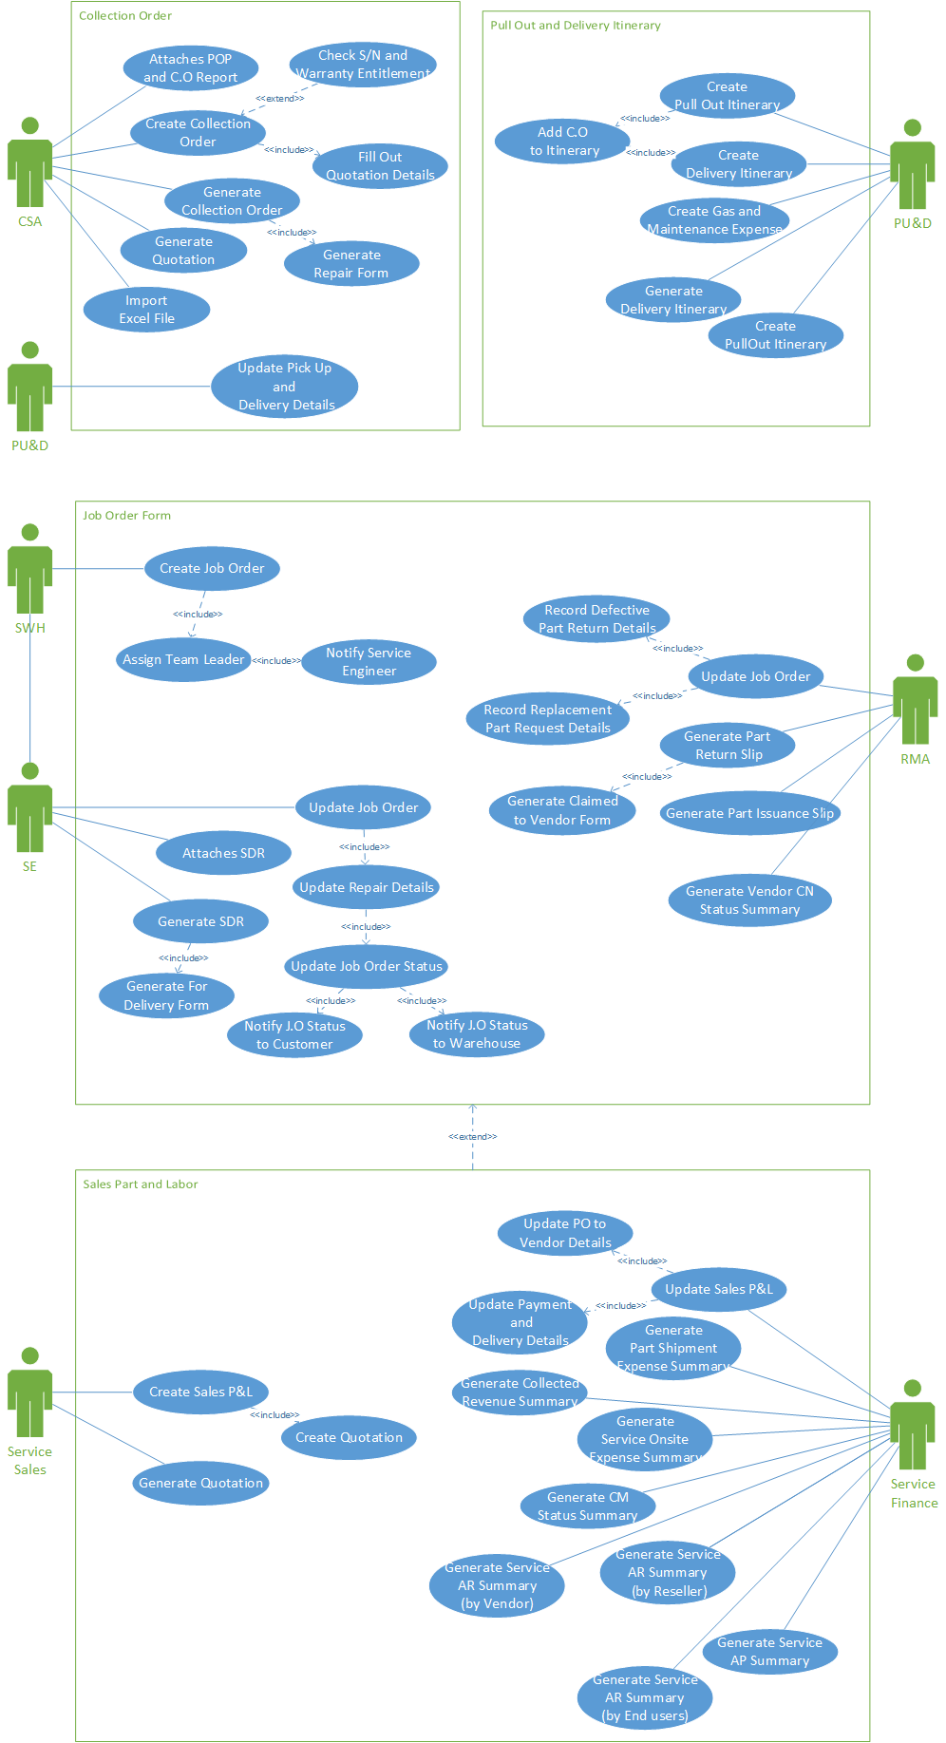

Figure 1: Use Case for Pick up Collection Order

### Use Case for Carry in Collection Order

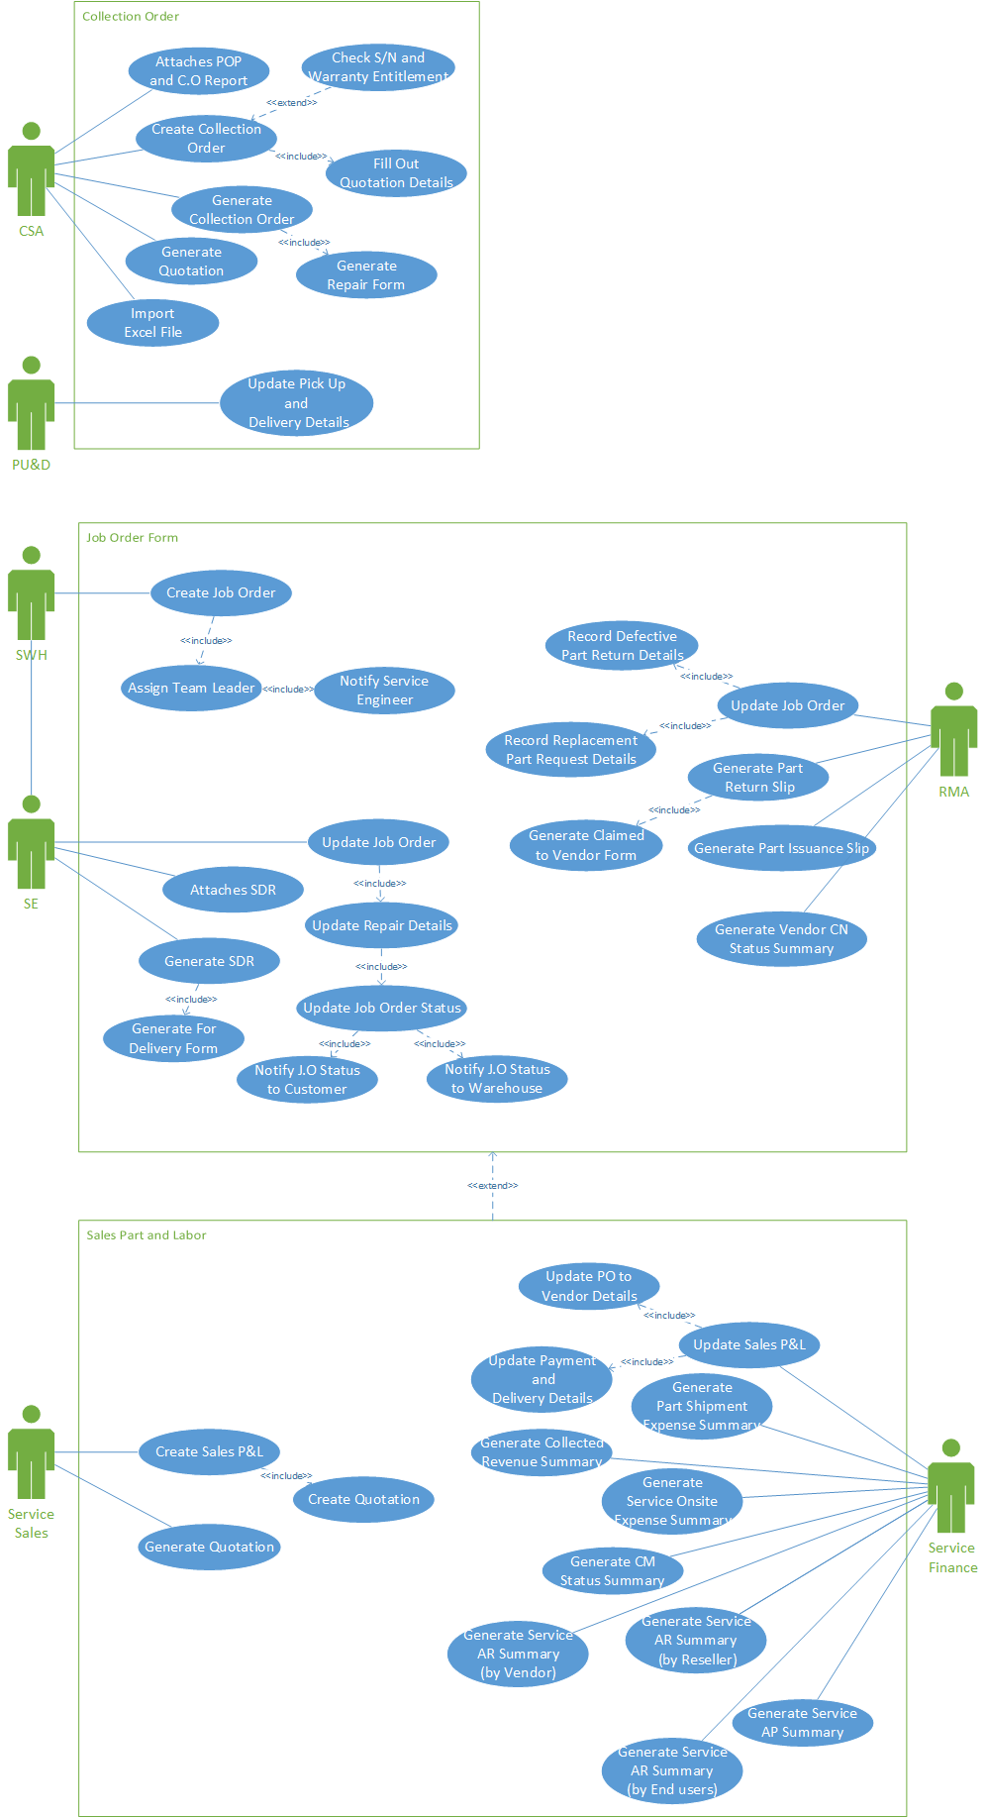

Figure 2: Use Case for Carry in Collection Order

### Use Case for Onsite Collection Order

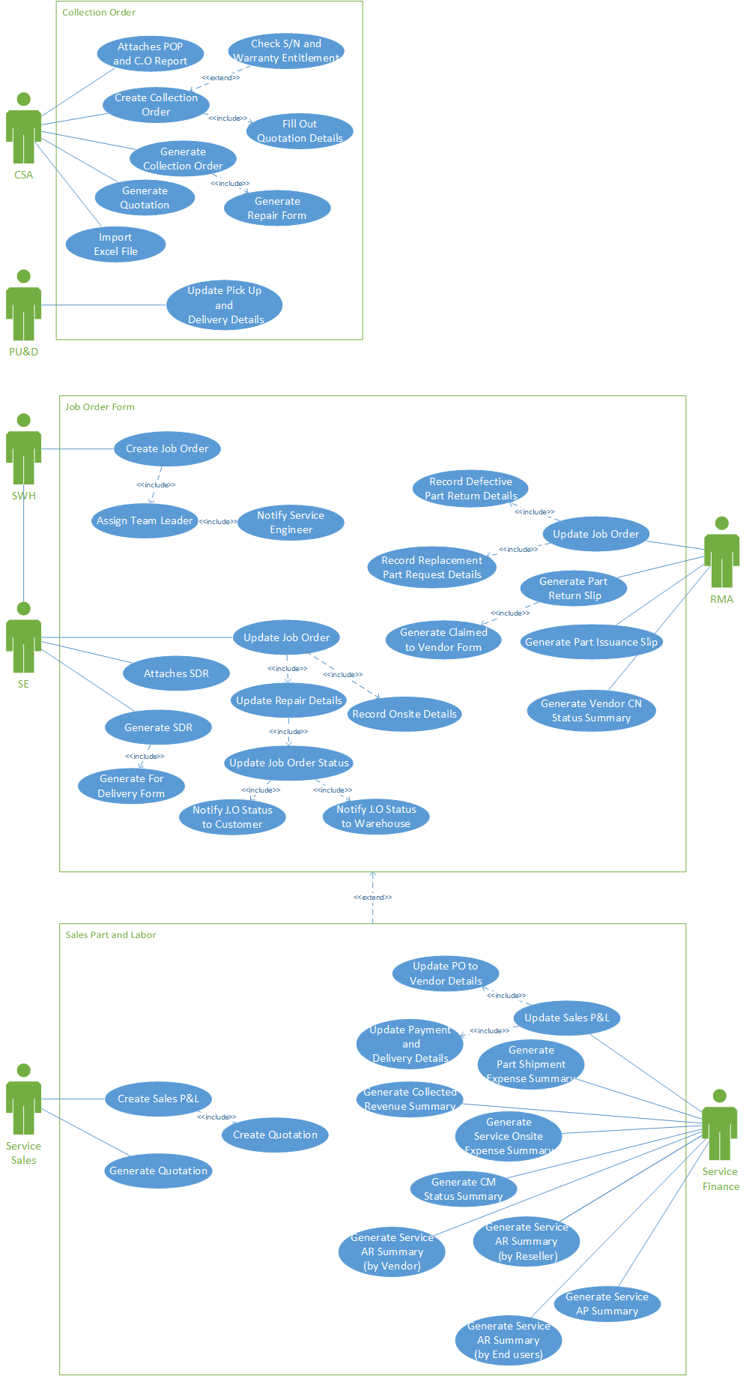

Figure 3: Use Case for Onsite Collection Order

### Use Case for Part Purchase

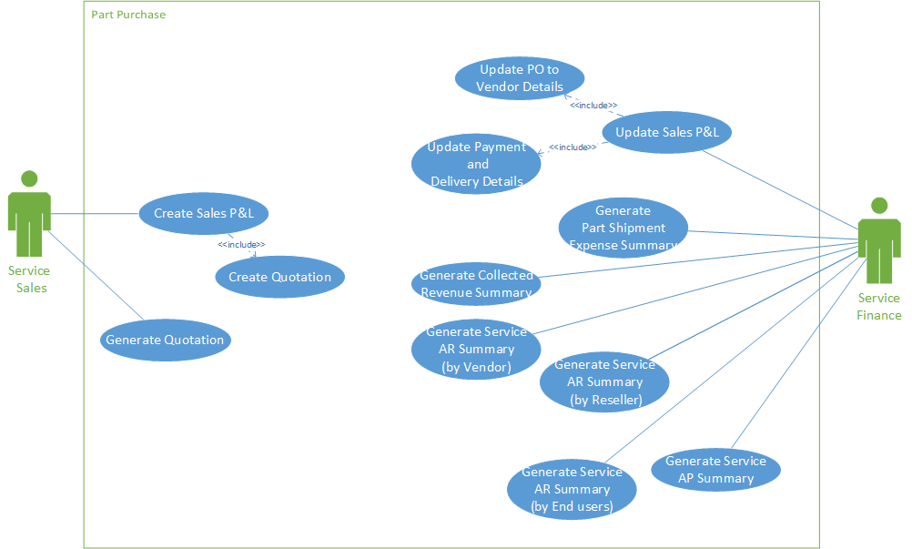

Figure 4: Use Case for Part Purchase

### Use Case for PU&D Waybill and PU&D Gas and Maintenance Expense

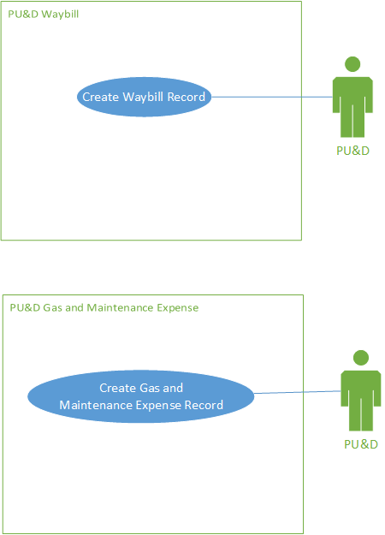

Figure 5: Use Case for PU&D Waybill and PU&D Gas and Maintenance Expense

## Data Flow Diagram

### Level 1 of Customer Service Management

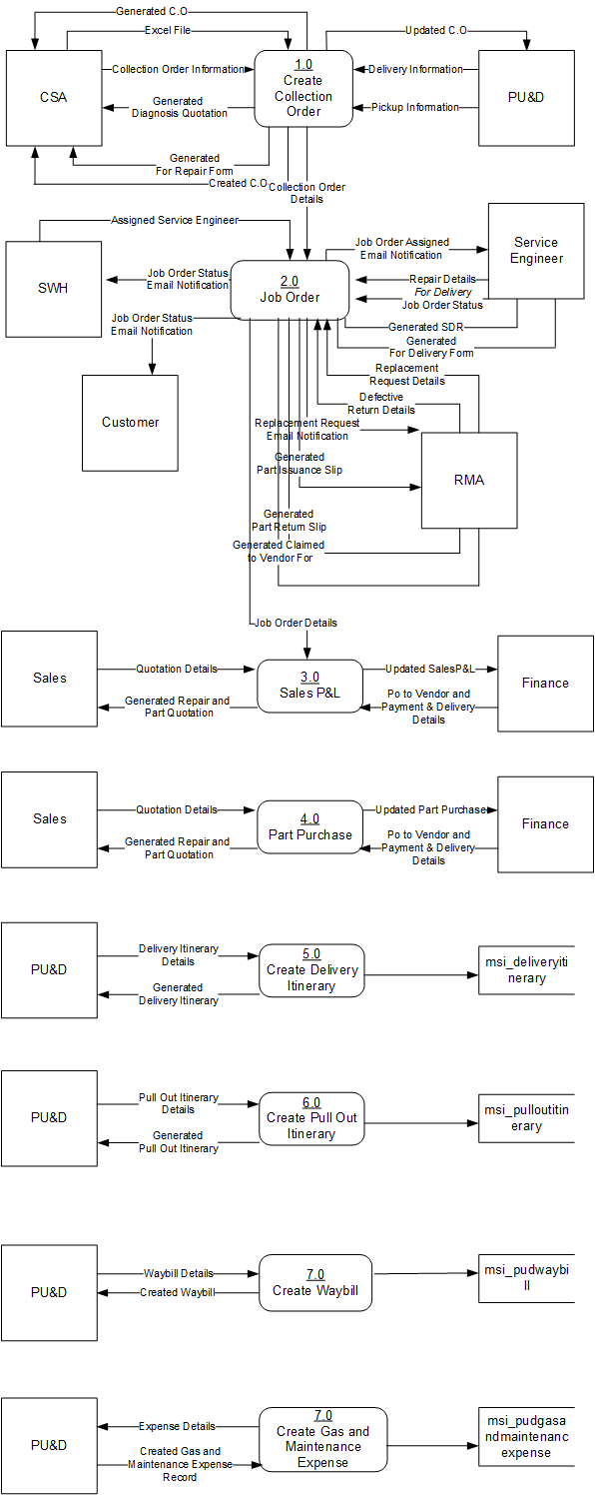

Figure 6: DFD Level 1 of Customer Service Management

### Level 2 of Collection Order

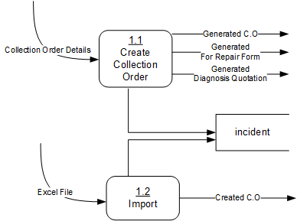

Figure 7: DFD Level 2 of Collection Order

### Level 2 of Job Order

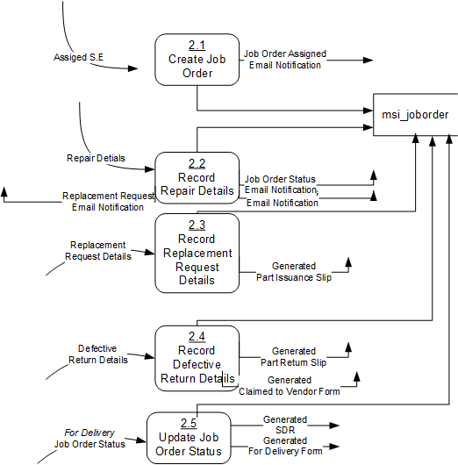

Figure 8: DFD Level 2 of Job Order

### Level 2 of Sales P&L

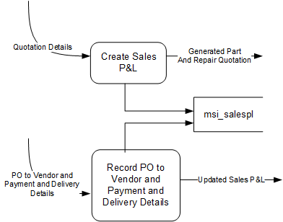

Figure 9: DFD Level 2 of Sales P&L

### Level 2 of Part Purchase

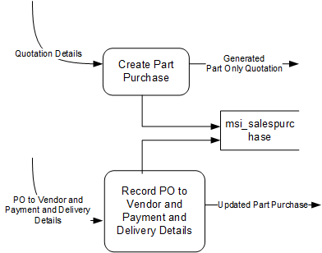

Figure 10: DFD Level 2 of Sales P&L

## Entity Relationship Diagram

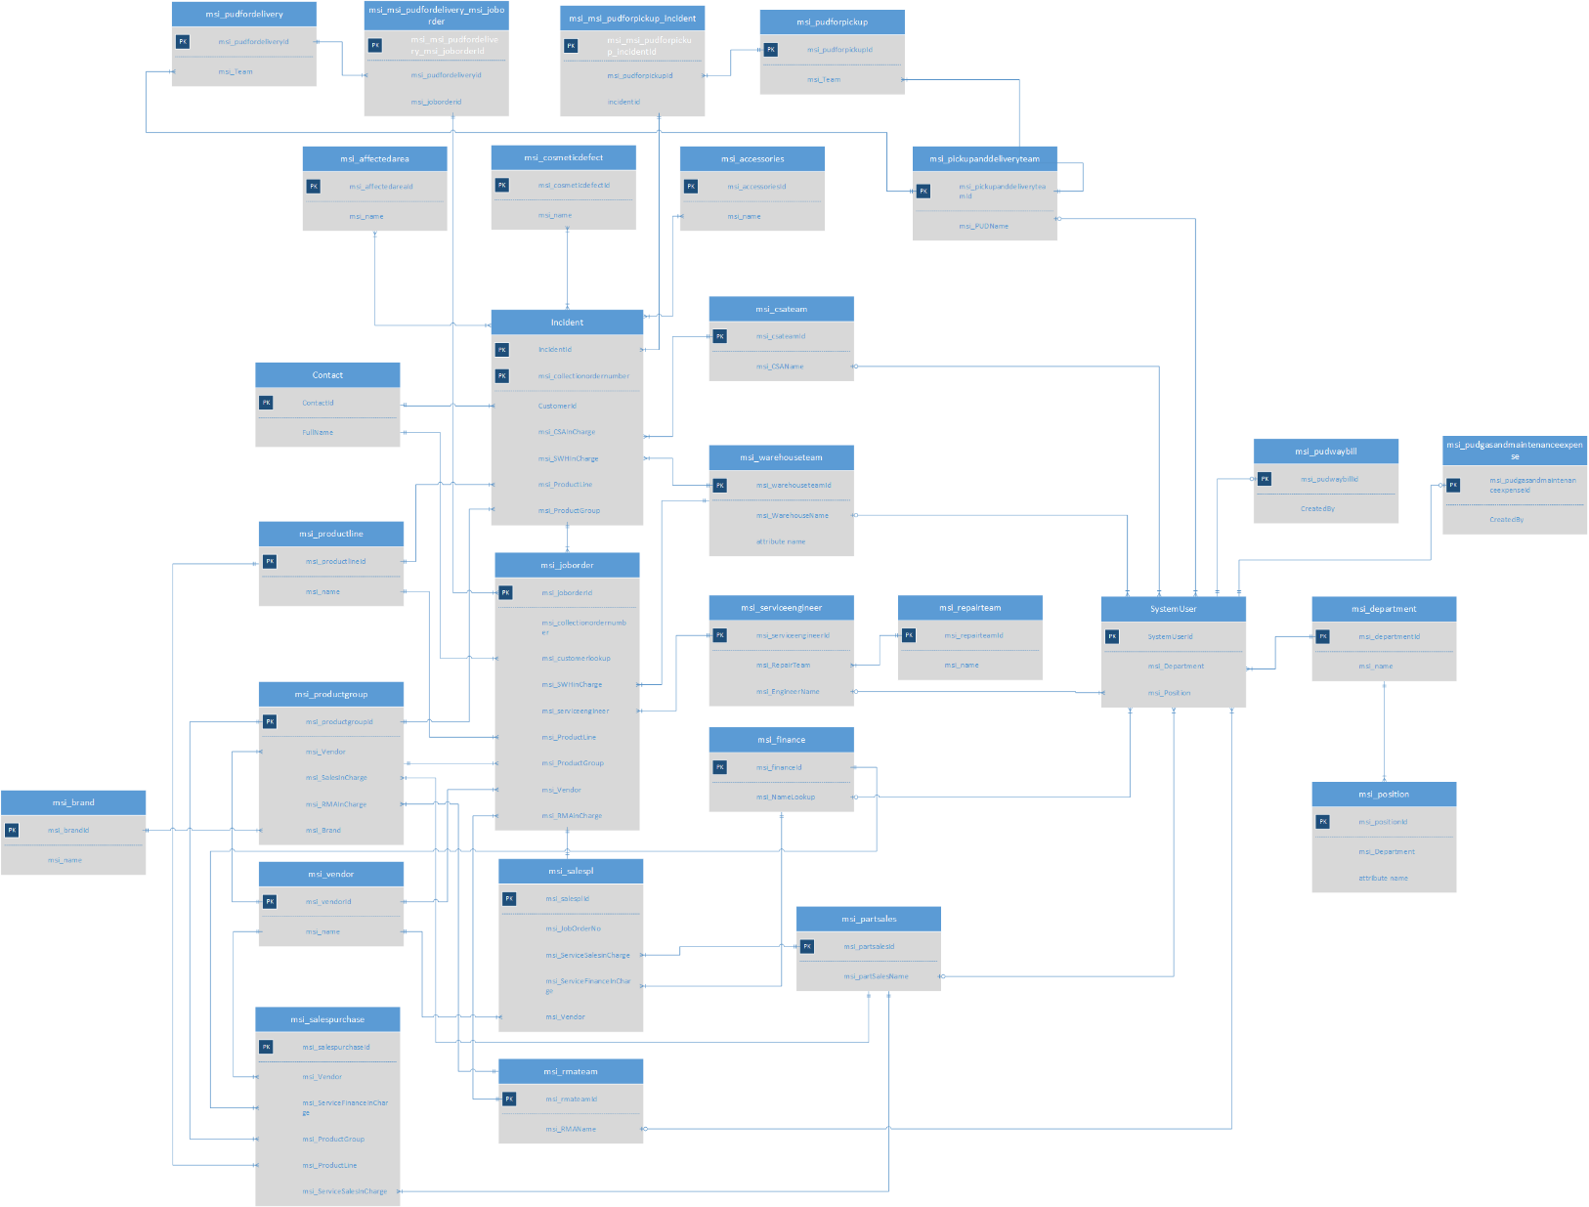

Figure 11: Entity Relationship Diagram of MSI Customer Service Management